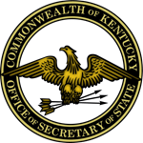

Alison Lundergan Grimes
Secretary of State and Chief Election Official

NOTICE and AGENDA
2014 Election Integrity Task Force Meeting
November 18, 2014
State Board of Elections, 140 Walnut Street, Frankfort, KY
2:00 p.m.

Secretary of State Alison Lundergan Grimes:
- Welcome/Call to Order
- Introduction of members and guests

Agency Reports:
- Kentucky State Board of Elections
- United States Attorney’s Office, Eastern District
- United States Attorney’s Office, Western District
- Federal Bureau of Investigation
- Kentucky Attorney General’s Office
- Kentucky State Police

Schedule Next Meeting

Adjournment

