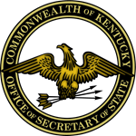

Alison Lundergan Grimes
Secretary of State and Chief Election Official

AGENDA
2014 Election Integrity Task Force Meeting
June 3, 2014, 2:00 p.m.
State Board of Elections, 140 Walnut Street, Frankfort, KY

Secretary of State Alison Lundergan Grimes:
- Welcome/Call to Order
- Introduction of members and guests
- Approval of Minutes from April 15, 2014, meeting
- Primary Election Day Re-Cap

Agency Reports:
- State Board of Elections
- Kentucky Attorney General’s Office
- United States Attorney’s Office, Eastern District
- United States Attorney’s Office, Western District
- Federal Bureau of Investigation
- Kentucky State Police

Schedule Next Meeting

Adjournment

